Day 6: 31st May – 113195064 – Bondili Bhavya Charitha

**TASK:1 – Regular Expressions and their explanation:**

* . = one character except newlines
* ^ = Start of a line/string
* $ = End of the line/string
* ? = Zero or one of the preceding elements
* () = Groups expressions
* [] = Defines a character class
* *= Zero or More number of elements

**TASK:2 – Features of Linux:**

* It can run multiple programs without lags.
* Several users can use the system at a same time as it is freely available so that anyone can view and modify it.
* Different tools can be installed securely.
* Kernels can run at a long time without rebooting.
* It supports many file systems and it rarely crashes.

**TASK:3 – What is kerel?**

It is a core part of an operating system because it like a middleman between my hardware (CPU) and software(apps).

Ex: Just like a swiggy. Kernel is a Delivery agent. He talks to the restaurant, picks my order and bring my food. As kernel talks to hardware, picks my resources and will give my data.

**TASK:4 – BASH in Linux full form and Explanation:**

Bash – Bourne again shell

It is a command line interface and a scripting language is used to automate the tasks.

**TASK:5 – Difference between Linux and Windows?**

* Linux is a free of cost and windows is a paid one.
* Linux is a more secure and windows can be attracted to malware (Hackings).
* Linux is command line interface + graphic user interface and windows mostly have graphic user interface only (cmd/power shell).
* Linux has package managers (apt,dnf) and windows has installers (.exe and .msi).
* Linux performance is very fast and windows performance is slow (sometimes lags).

**TASK:6 – Basic components of Linux and describe each with diagrams?**

* User Space (Applications) – Here end users interact with the system and has the programs like text editors, audio/video players and browsers.
* Shell – It acts as an intermediate between user and kernel. CLI and GUI includes in this.
* Kernel – It is a main part of an operating system because it like a middleman between my hardware (CPU) and software(apps).
* Hardware layer – It includes CPU, RAM and Hard disk. Kernel directly connects with this hardware layer using drivers.

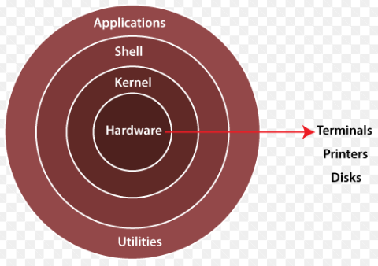

**TASK:7 – Is it legal to edit kernel? When do you think we have to in case?**

Yes, it legal only because linux kernel is a open source. We can use, modify and share.

* When we are developing a new hardware (Customized motherboard) then we have to modify the kernel.
* For robotics/ music productions, due to low latency cases, we need to improve those performance.
* Researchers will work on how OS internals works, developing new kernels behalf of their experiments.

**TASK:8 – What is LILO? Explain.**

* LILO means Linux Loader which is a programme for linux OS. Which loads the kernel in to the memory and starts the OS upon system is active.
* It supports multiple OS, fast and have simple config.

**TASK:9 – What is shell? How many shells are there and what are they?**

Shell is a program that acts as a middle man between user and OS. It allows us to run the commands and execute the scripts.

Types of Shell:

* BASH – Bourne again shell, SH – Bourne shell, ZSH – Z shell, CSH – C shell
* BASH is a most common shell (default) in linux, it is userfriendly.
* SH – It is simple and portable.
* ZSH – It has many features (themes, plugins).
* CSH – Uses C like syntax.

**TASK:10 – What is swap space?**

It is a backup memory that helps to prevent system crashes when it runs out of ram.

**TASK:11 – What is mount? How do you mount and unmount file system in linux?**

* Mount is a process of making storage device accessible to linux file system by attaching it to a mount point (dir)
* After identifying a device, we have to create a mount point then we will mount the devicenlater we will verify the mount.
* When we finish using our device, we can unmount it.

**TASK:12 – What is chmod command? How to use it?**

Chmod command is a linux command which is used to change the permissions (Read/write/Execute) of files and directories.

Syntax: options permissions file

**TASK:13 – Can you add a new user account? Create a new user in different ways and paste SS.**

Yes we can do.

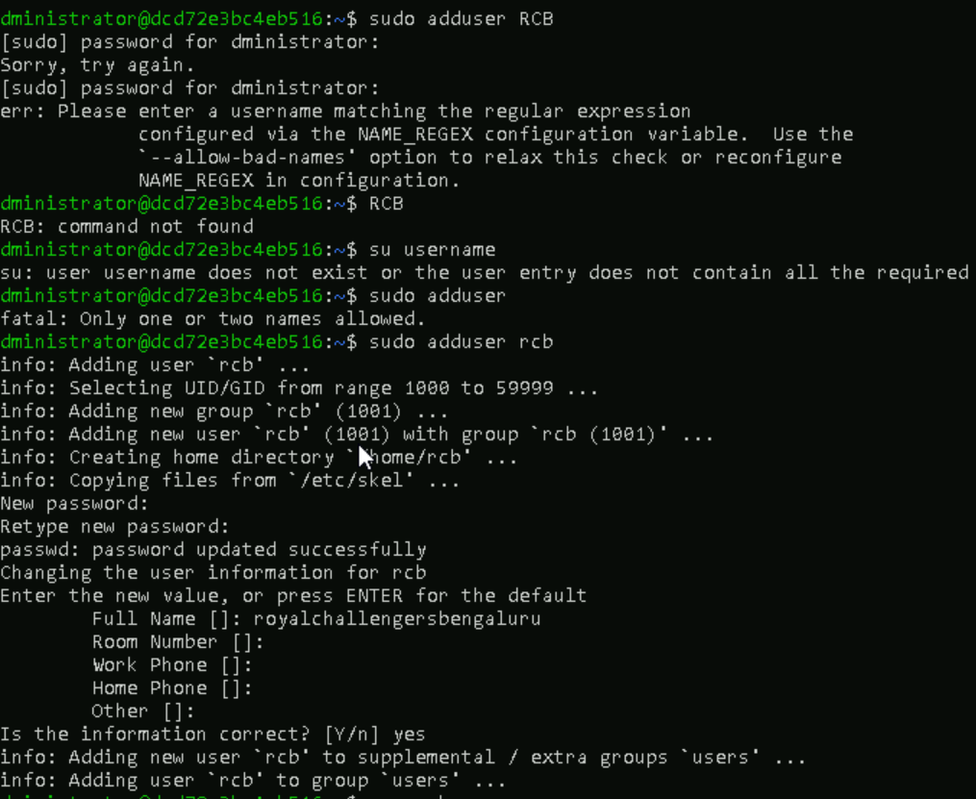

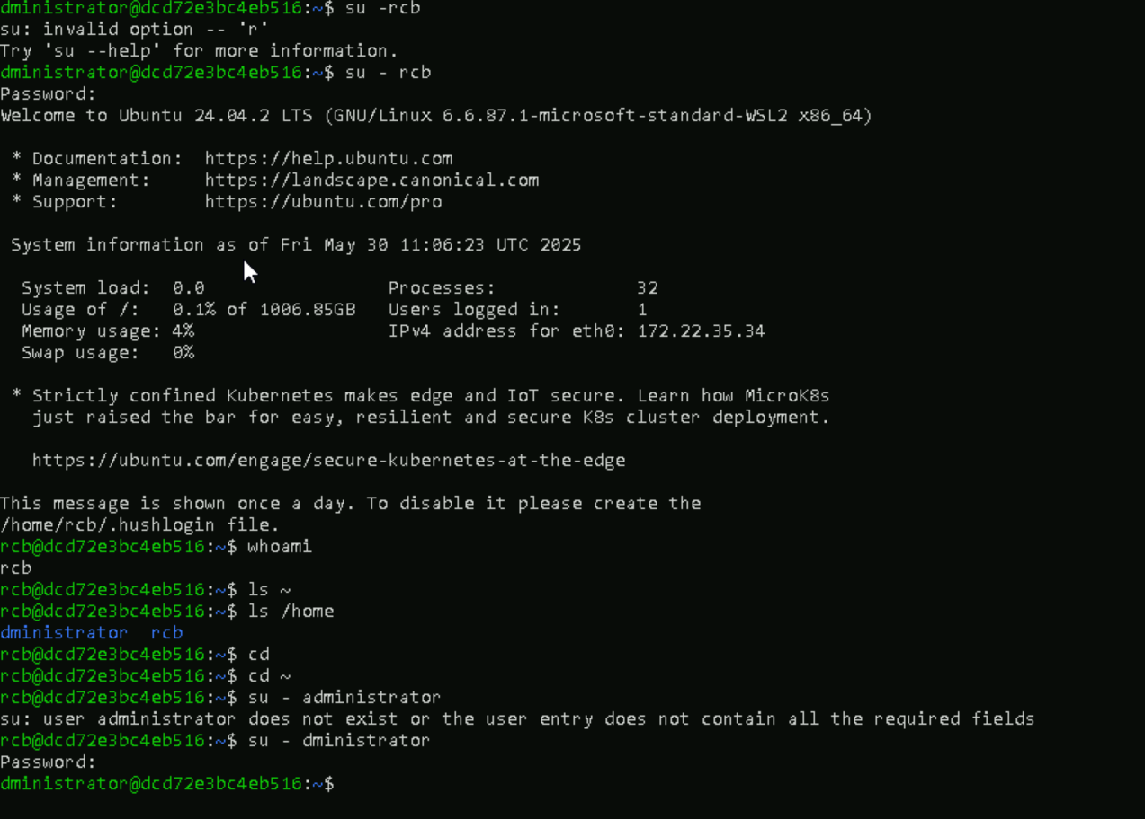

**TASK:14 – Can you change the password of a user? How do you do that? SS**

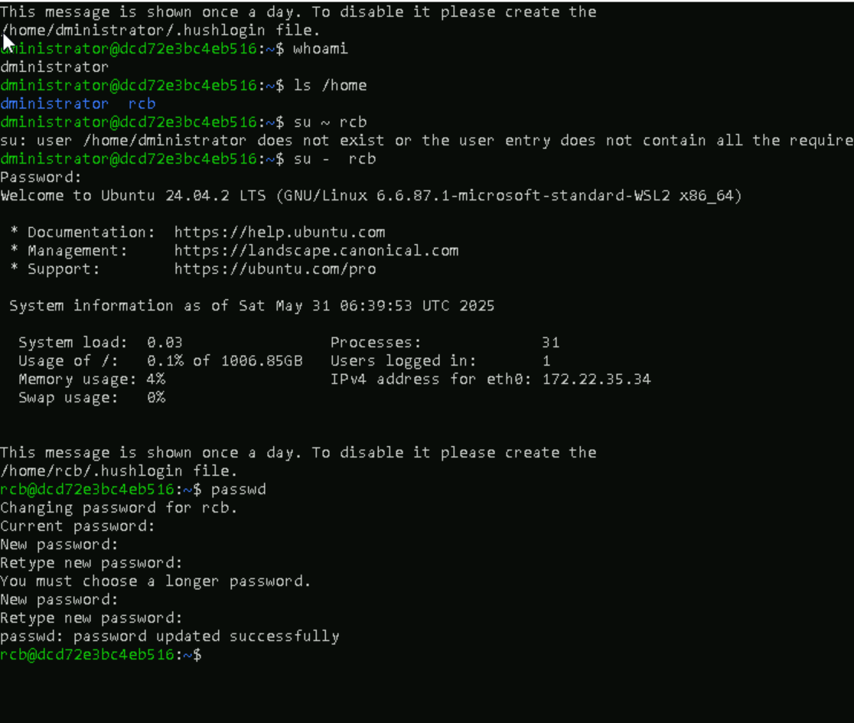

**TASK:15 – Difference between process and thread?**

Process: A process is an individual program in execution as it has its own memory space. If one process crashes, it won’t affect whole process.

Ex: Firefox.

Thread: A thread is a smaller unit within a process. A process can have multiple threads (multithreading). It shares the memory and resources with other threads also. If one thread crashes, it effects whole process (Ex: Cadbury Gems advertisement, if man pulls out one gem in group of gems, all that collapsed).

Ex: A web browser has threads for downloading files, etc.

**TASK:16 – LINUX GREP Commands**

1. Case sensitive search

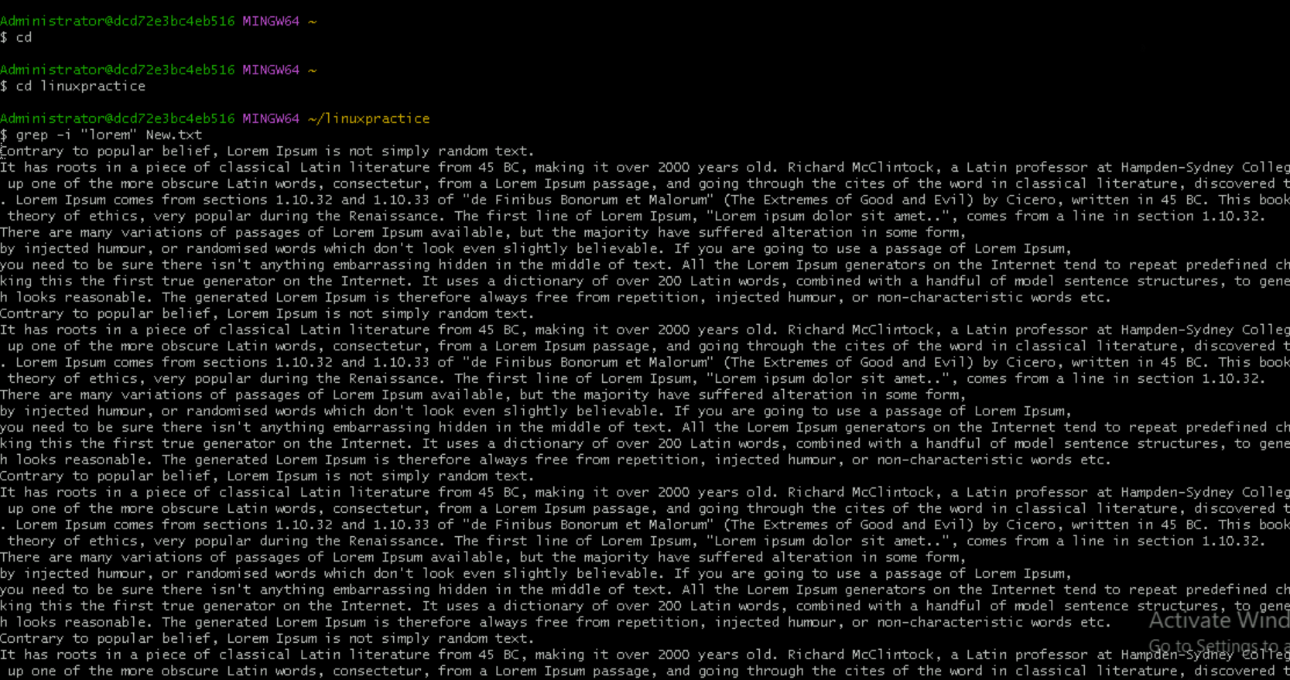

1. Displaying the count of Number of matches using grep

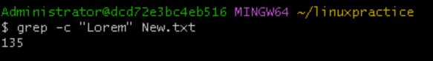

1. Display the file names that matches the pattern using grep

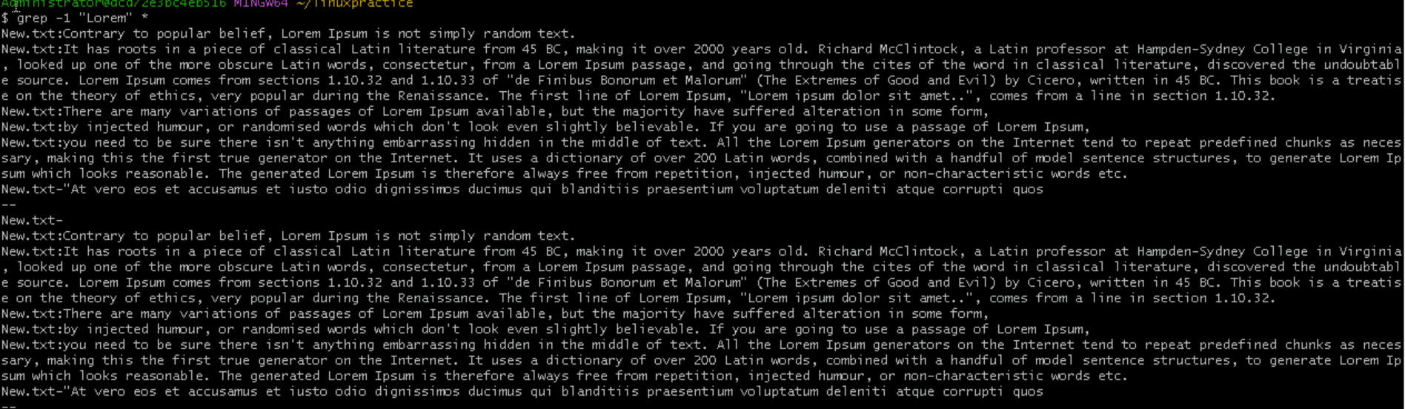

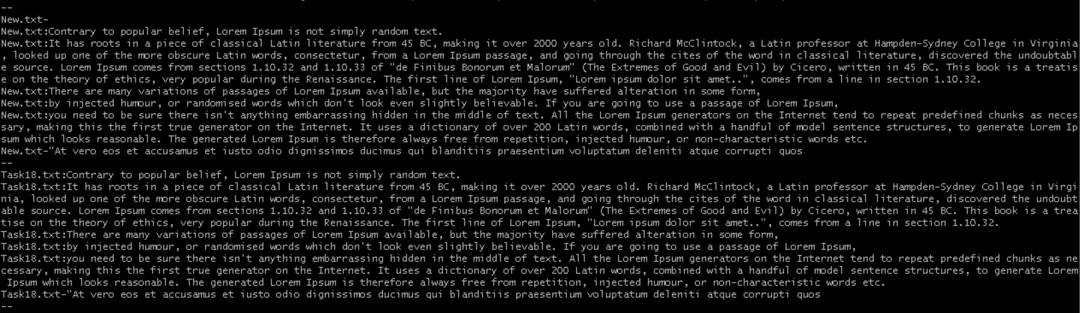

1. Checking for whole words in a file using grep

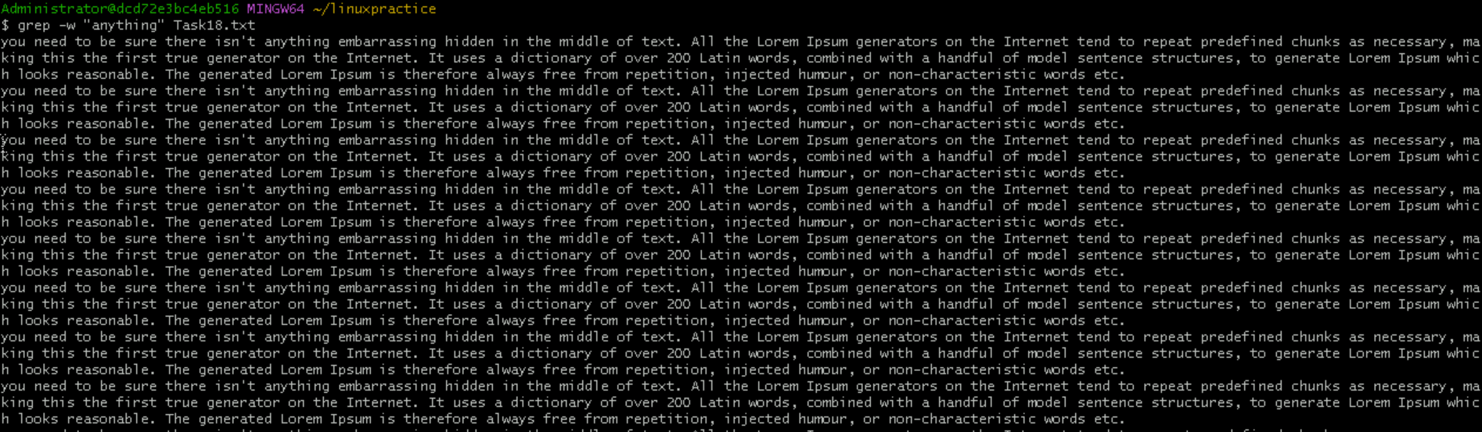

1. Displaying only the matched pattern using grep

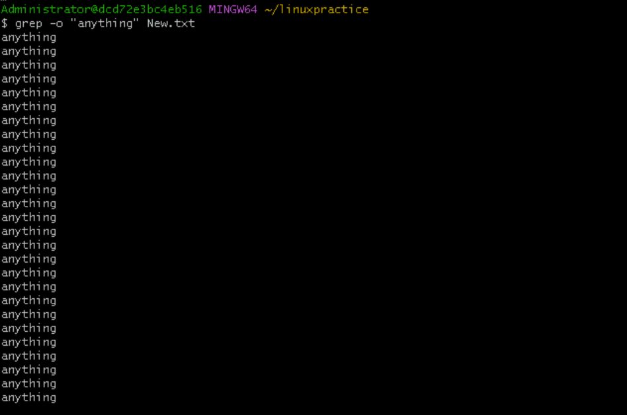

1. Show line number while displaying the output using grep

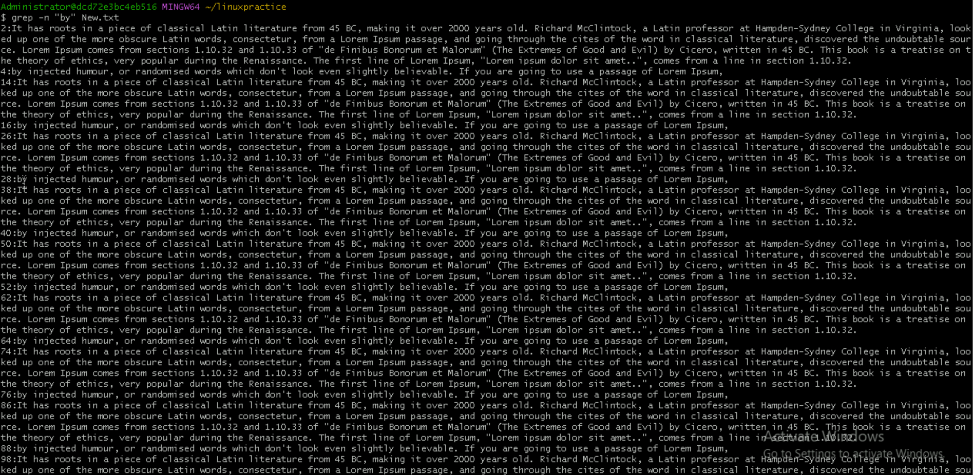

1. Inverting the pattern match using grep

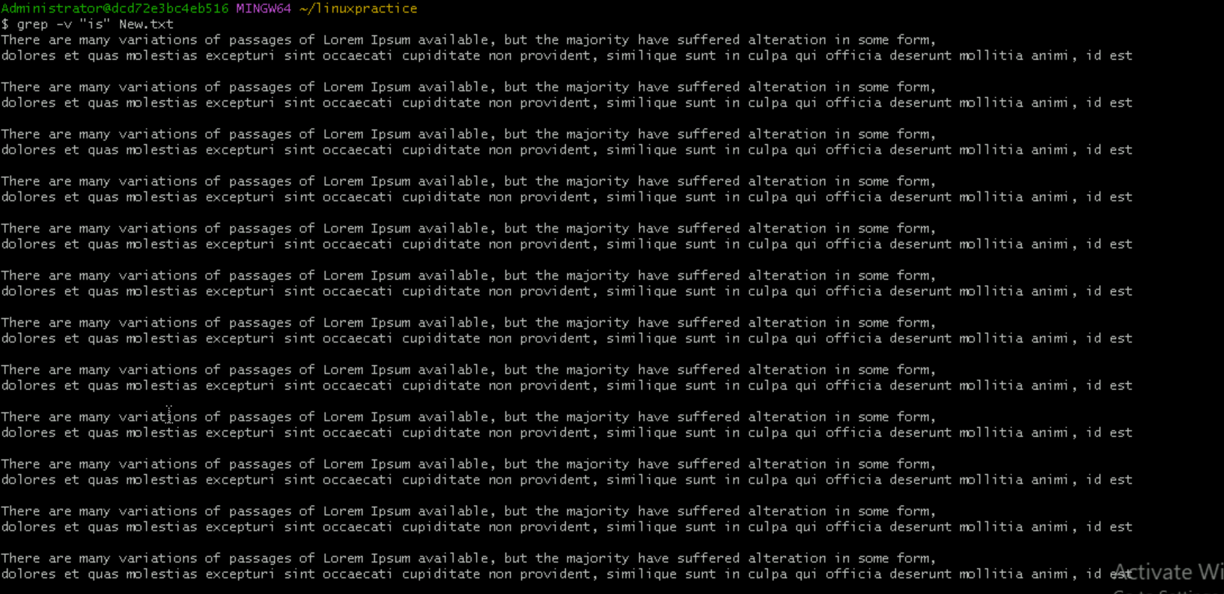

1. Matching the lines that start with a string using grep

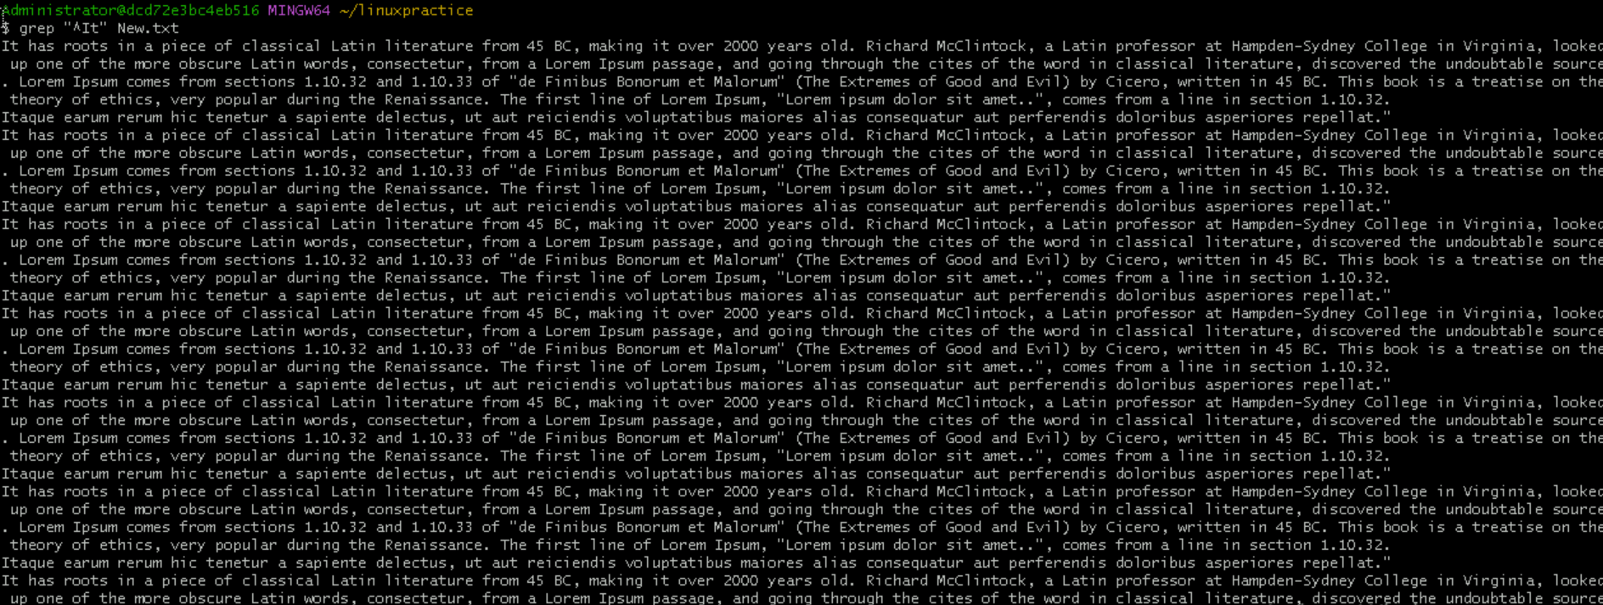

1. Matching the lines that end with a string using grep

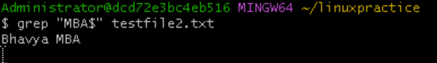

1. Specifies expression with -e option.

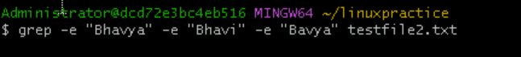

1. -f file takes patterns from file, one per line

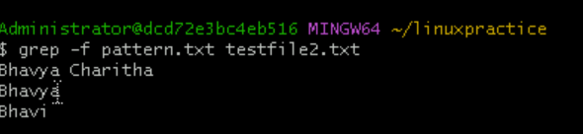

1. Print n specific lines from a file using grep



1. Search recursively for a pattern in the directory



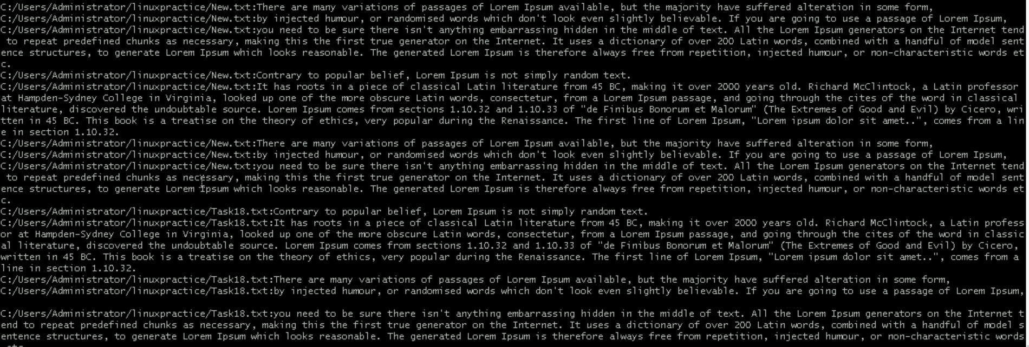

TASK:17 – AWK Commands

1. Print contents of a file

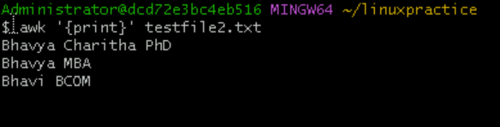

1. Print specific columns of a file (1st and 3rd columns)

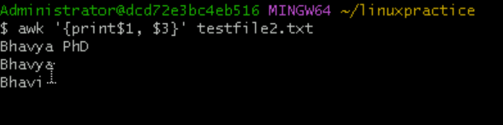

1. Filter lines based on a condition

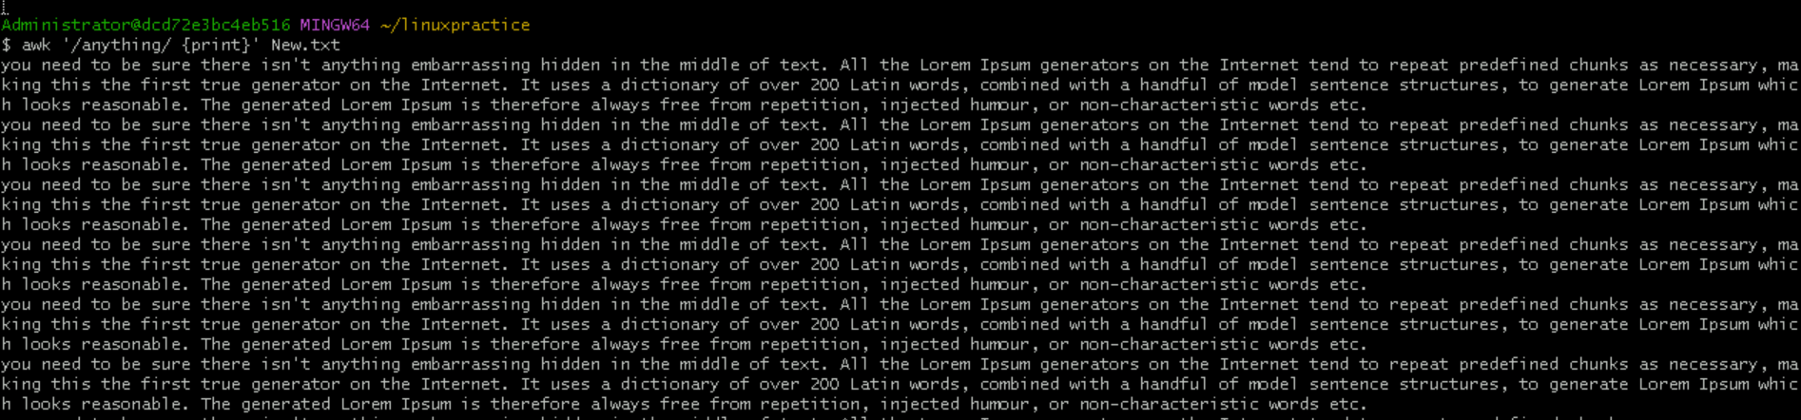

1. Sum values in a column

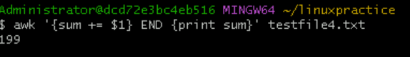

1. Extract substring from a column

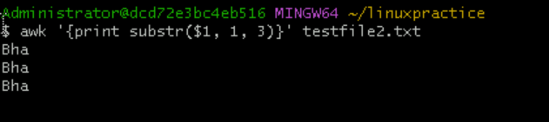

1. Join two files based on a common column

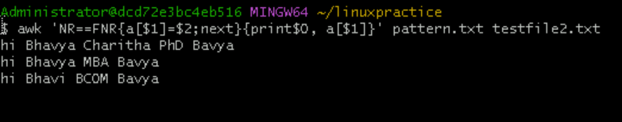

1. Extract first column of a file

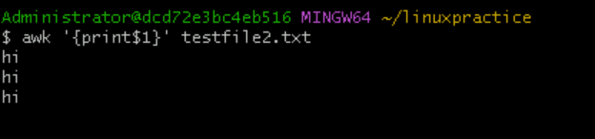

1. Calculate average of a column

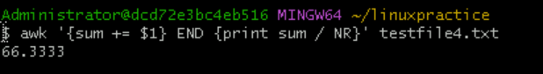

1. Replace a string in a file

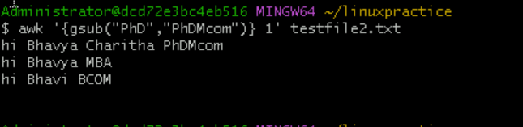

1. Display last field of a file

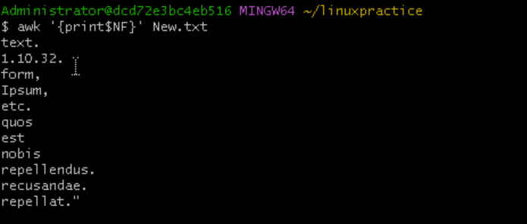

1. Using Regular Expressions



1. Using variables

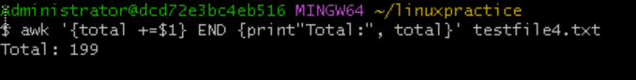

1. Using control statements

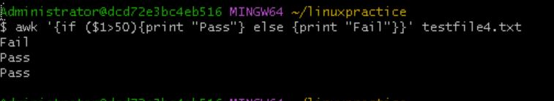

1. Using Functions

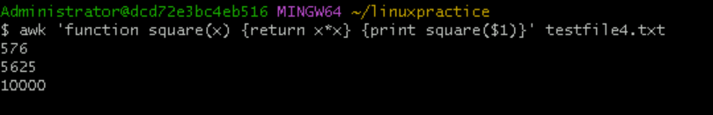

**TASK:18 - How to check file access permission in Linux?**

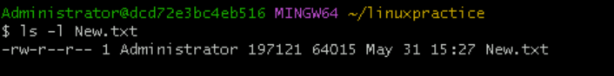

**TASK:19 - What are the default permissions for a new file? (No SS required)**

When we create a new file in Linux, the default permissions are as follows:

Owner – Read and Write = rw-

Group – Read Only = r--

Others – Read only = r—

**TASK:20 - What is the command to change the permission to read only for the owner, group and all other users**

Chmod 444 testfile4.txt – it will change the permissions.

**TASK:21 - Can you change the file permissions to match the following:**

**owner: Read and Write**

**group: Read**

**other: no permissions (None)**

Yes, we can do with chmod 640 testfile2.txt

Owner – 6 – rw- Read and write

Group – 4 – r-- - Read only

Others - --- - No permissions.

**TASK:22 - What was the command for changing the file permissions to -rw-r-----?**

chmod 640 testfile2.txt

**TASK:23 - Change chmod.exercises permissions to -rwxr-x--x**

**Change the file permissions to match the following:**

**owner: Read, Write and Execute**

**group: Read and Execute**

**other: Execute**

To change these we have to give chmod 751 chmod.exercises

Owner – 7 – rwx – full access

Group – Read and Execute – 5 – r-x

Others – 1 – Execute only - --x

**TASK:24 - What was the command for changing the file permissions to -rwxr-x—x?**

Chmod 751 testfile2.txt

**TASK:25 - what will this command do?**

**chown -c master file1.txt**

It will show error because this command assigns ownership to the user. So it requires atleast one user not a text file.

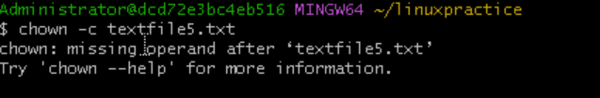

**TASK:26 – Can you define what is a process?**

Process is an instance of a program. When we open an app or runs a command, Linux creates the processes to manage that activity.

Ex: I walked to the Dakshin café and says, one filter coffee (running the command)

Dakshin café starts preparing filter coffee – this is the process.

**TASK:27 - What is command to check foreground process and background process?**

For foreground process – Ctrl+Z (current terminal)

For background process – jobs (list of jobs started in present shell).

**TASK:28 - Can you list all the running processes?**

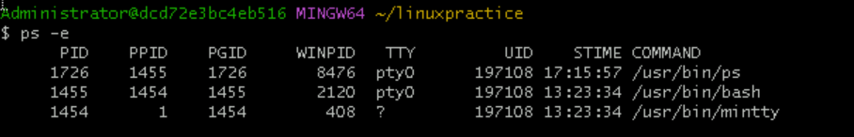

**TASK:29 - What will ps -f command do? (ss required)**

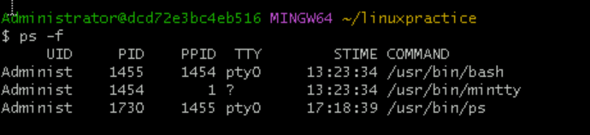

My ubuntu is not working properly. So worked on these scripts in git bash.

**TASK:30 - Can you create a variable name with your name in it**

**Ex: Name = “prasunamba”, Id = 10001 and check Echo $Name Check the output**

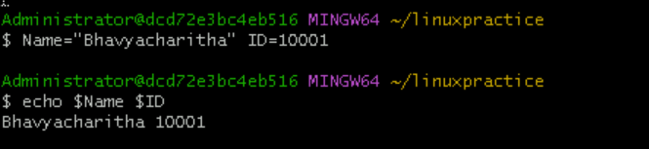

**TASK:31 - Can you make the above name variable read only..**

**Ex: Name = “Prasunamba” Readonly Name. Name = “Meher” —>what will this display. Is it saying read only??**

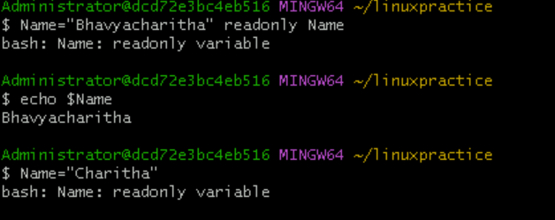

**TASK:32 – Unset or Delete the variables**

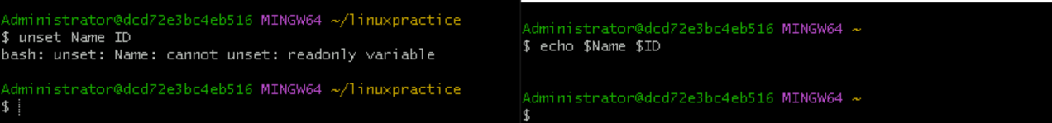

I have put my variable (Bhavyacharitha) is readonly, so until and unless I open a new session, I can’t modify it.

**TASK:33 – Can we try to add a list of your friend’s names in an array and try to printout?**

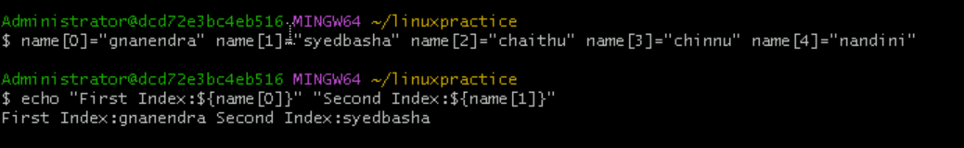

**TASK:34 - Can you print all the list at once in an array?**

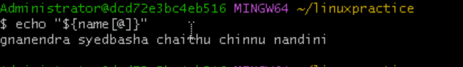

**TASK:35 – What is the output of below snippet?**

